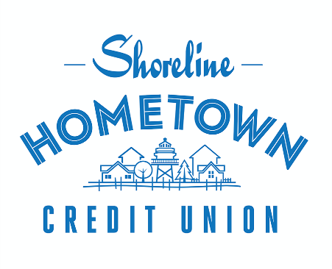
March 28, 2023

FOR IMMEDIATE RELEASE

CONTACT:
Mike Johnson
Marketing Specialist
Phone: 920.482.3730

JohnsonM@ShorelineCU.org

Shoreline Hometown Credit Union Continues to Expand
Manitowoc, Wis., March 28, 2023– Shoreline Hometown Credit Union has announced the appointment of Brad Schneider as Financial Consultant at its Green Bay branch. In his new role, Brad is responsible opening new deposit accounts, underwriting and approving consumer loans, and finding products and services based on member’s needs.
Brad says, “One thing I am excited for about working here is helping members achieve their financial goals. I’m excited to work with individual members to plan for their future and assist them in any way I can to make sure they feel welcomed at Shoreline.” Brad has prior experience in the financial industry, as well as a strong background in customer service, which will enable him to determine members’ needs and make suggestions to increase their financial well-being.
Brad brings a fresh perspective to Shoreline as our Green Bay branch blossoms in its first year. Brad has a Bachelors in Sociology from the University of Wisconsin-Milwaukee, as well as an Associates in Computer Science. Brad will help represent Shoreline Credit Union in the community as a member of the Greater Green Bay Chamber Young Professionals. You can also find Brad on the golf course or enjoying a video game. If you are looking to open an account, finance a car, or open a personal loan, stop on by and see how Brad can help you.
About Shoreline Credit Union
For over 80 years, Shoreline Hometown Credit Union has served as a member-owned, non-profit financial cooperative. With headquarters in Manitowoc County, Wisconsin, it has approximately 8,000 members
in nine counties — Brown, Outagamie, Winnebago, Door, Calumet, Fond du Lac, Kewaunee, Manitowoc,
and Sheboygan.
###

