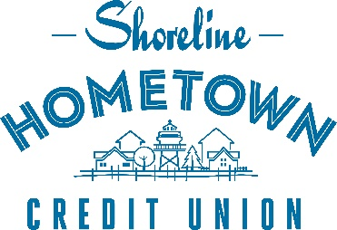

March 2, 2023
FOR IMMEDIATE RELEASE:
CONTACT:
Steve Haensgen
Chief Financial Officer
Phone: (920) 482-3779
Marketing@ShorelineCU.org
SHORELINE HOMETOWN CREDIT UNION AWARDED WEYENBERG PRIZE FOR LEADERSHIP, STRATEGY, AND EXECUTION

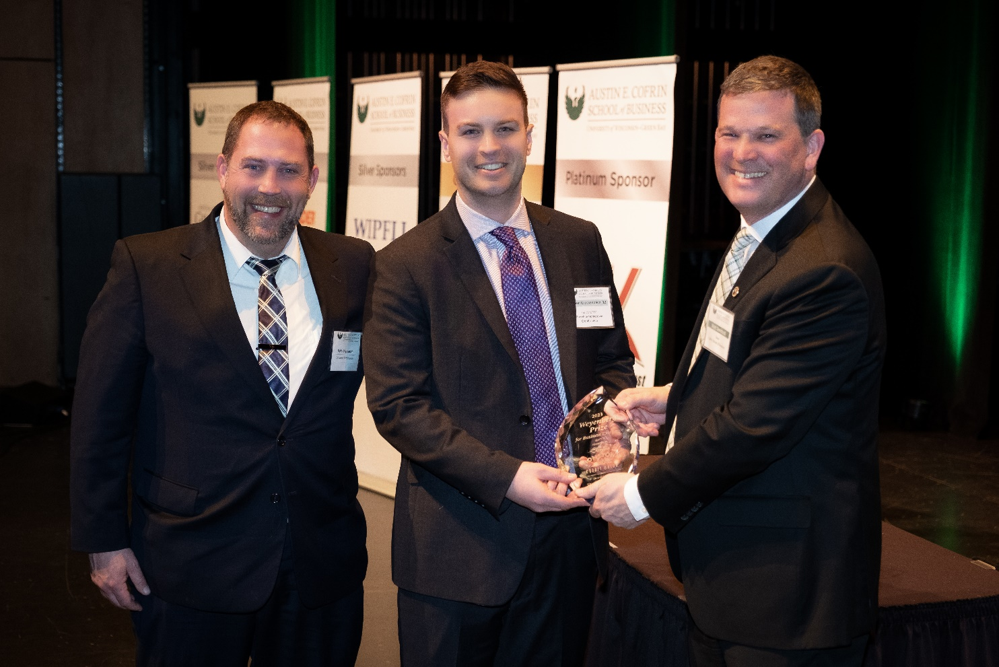
Pictured Left to Right Kyle Bryntesen Community Outreach Officer (Shoreline Hometown Credit Union), Nathan Grossenbach President & CEO (Shoreline Hometown Credit Union), Mathew Dornbush Dean of the Cofrin School of Business (University of Green Bay).

Shoreline Hometown Credit Union is proud to announce it was named the 2023 Small Business Weyenberg Prize winner. The Weyenberg prize, co-sponsored by UW-Green Bay and InitiativeOne Leadership Institute, seeks to recognize business excellence where leadership transformation, strategy development, and strategic execution are critical components of the organization’s corporate culture.
Shoreline President and Chief Executive Officer, Nathan Grossenbach, says, “This award means a tremendous amount to our organization. We strive to live out our Hometown Values at every level of our organization. While this is validation of the work we have accomplished, it also sets our internal bar for future excellence even higher.”
Shoreline was specifically recognized for its efforts in providing accessible and affordable financial services to communities that are statistically less likely to be served, including the low income, poor credit, or non-English speaking communities.
“Shoreline Credit Union has built its base on providing no-fee checking accounts, flexible lending arrangements to those with either impaired or little credit, and providing second chances to those who need it,” says Kyle Bryntesen, Community Outreach Officer of Shoreline. “We have changed the financial lives of many members who simply could not get approved or even open an account at other financial institutions. One of our core values is ‘Genuine’, and I truly feel our employees deeply care about the personal success of our members.”
The Weyenberg Prize was created in recognition of Tim Weyenberg’s personal, business, and community impact. Annually, UW-Green Bay’s Austin E. Cofrin School of Business and InitiativeOne present the award to a Small Business and a Large Business. Past winners include Schneider National, Festival Foods, AriensCo, WIPFLI, and KI.
“The Prize has previously recognized several highly impactful businesses in our area,” says Gretchen Bauknecht-Pech, Board Chair of Shoreline. “It is exciting to see our efforts have culminated in an honor such as the Weyenberg Prize. To be categorized amongst great organizations who have previously won is truly humbling. We look forward to carrying these values forward!”
About Shoreline Credit Union
For over 80 years, Shoreline Hometown Credit Union has served as a member-owned, non-profit financial cooperative. With headquarters in Manitowoc County, Wisconsin, it has approximately 8,000 members in nine counties — Brown, Outagamie, Winnebago, Door, Calumet, Fond du Lac, Kewaunee, Manitowoc, and Sheboygan.
###

